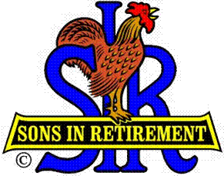
Las Trampas Branch 116
BEC Meeting Agenda
February 18, 2019, 9:30 AM
The Mission of SIR is to improve the lives of our members through fun activities and events – while making friends for life.

09:15 Coffee Available
09:30 Call to order; Secretary confirm a quorum
09:31 Secretary – Fred Schafer – Approval of January minutes
09:33 Treasurer – Jim Nickels – Report, Missed Luncheon Receipts, Dues
09:36 Standing Reports
- Attendance – Jim Flessner – Attendance, Guest (Jim Dawes sponsor Dave Williams, and Lonnie Randall from Inactive)
- Membership – Phil Goff – Report, New Members to be inducted
- Nominating Committee – Marty Katz - Members
09:45 Officer, Director, RAMP Department Head Reports
1. Audit – Ron Armijo
2. Spring Fling – Alan Fitzgerald -
3. Nominating Committee – Marty Katz – Members
4. Activity Coordinator – Fred Wachowicz – Survey, Golf, Bocce
5. Publicity – Jim McCormick - Goals
09:55 Big SIR Report – Jerry Hicks
- Member Relations – Sam Beret
a. Orientation – Mike Schneider
- Luncheon seating
- State Townhall Meeting – Feb 12 at Rossmoor
a. Social Activity for Men – Getting away from Retirement
b. Insurance – Liability; D&O for Branches
c. Bring Guests to Activities, not just Luncheons
d. To change attitudes, you must communicate
e. Nominating Committee Training – Hopefully March
f. New Logo
g. New By-laws and policies, procedures
h. Emphasis on Recruiting
10:08 Little SIR Report – Michael Barrington
1. Speaker
2. Other

10:10 Old Business
- TBA
10:15 New Business:
- What to do if a member doesn’t pay dues?
- Central Source Buying of SIR items – Buyer
- New State Activity: RV’ing
10:20 Other Discussion
10:25 Adjourn; Next BEC Meeting, March 18, 2019, 0930

